QUIZ: A photographic essay on any important issue you may identify in the African community

Addressing Water Scarcity in African Communities

Dalmas Kiplangat Koskei

Communication skills

March 27, 2024

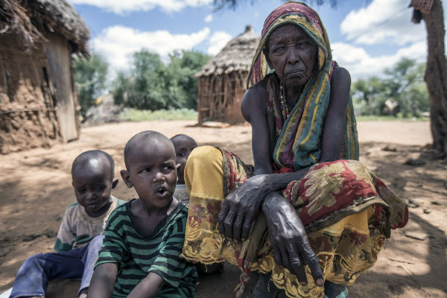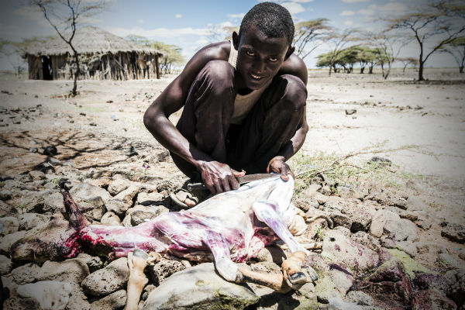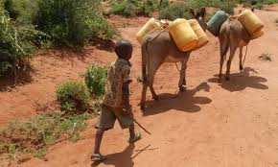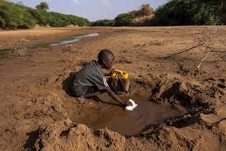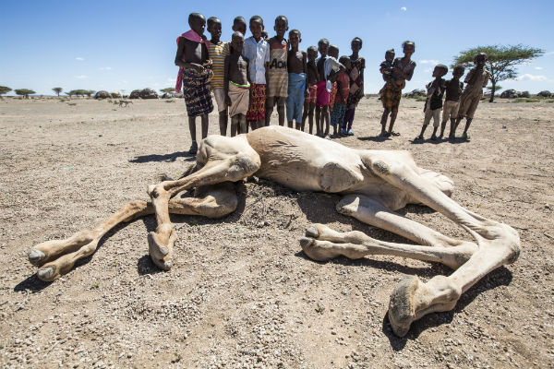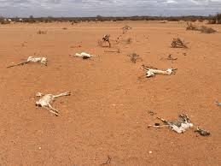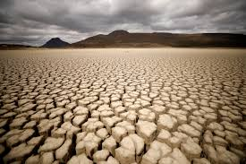

**INTRODUCTION**

Water scarcity remains one of the most pressing challenges facing African communities, affecting millions of people across the continent. While water is a basic human need and essential for life, access to clean and safe water is far from guaranteed for many African populations. This essay explores the issue of water scarcity in African communities, its underlying causes, and the urgent need for sustainable solutions to address this critical challenge.

In many parts of Africa, accessing clean and safe water is a daily struggle. Women and children, in particular, bear the brunt of this burden, often spending hours each day walking long distances to fetch water from distant and often contaminated sources. The lack of access to clean water not only poses significant health risks due to waterborne diseases but also perpetuates cycles of poverty and inequality, as communities are unable to meet their basic needs and pursue opportunities for development and growth.

One of the root causes of water scarcity in African communities is inadequate infrastructure and resource management. Many regions lack reliable water supply systems, and existing infrastructure is often poorly maintained or insufficient to meet the needs of growing populations. Additionally, factors such as climate change, deforestation, and pollution further exacerbate water scarcity by disrupting natural water cycles and degrading water quality.

The consequences of water scarcity extend beyond individual health and well-being to impact broader social and economic dynamics. For example, limited access to clean water can hinder educational opportunities, as children, particularly girls, are often tasked with water-fetching duties instead of attending school. Furthermore, water scarcity can impede agricultural productivity, as farmers struggle to irrigate crops and sustain livestock, leading to food insecurity and economic instability.

Despite these challenges, African communities demonstrate remarkable resilience and resourcefulness in the face of water scarcity. Many communities have implemented innovative solutions to address their water needs, such as rainwater harvesting, water purification techniques, and community-led conservation efforts. These initiatives not only provide immediate relief but also promote sustainable water management practices and empower communities to take control of their water resources.

However, addressing water scarcity in African communities requires a concerted effort from various stakeholders, including governments, NGOs, businesses, and international organizations. Investments in water infrastructure, sanitation facilities, and water conservation initiatives are crucial to improving access to clean water and sanitation services for all. Furthermore, promoting education and awareness about water conservation and hygiene practices can empower communities to make informed decisions and adopt sustainable behaviors.

In conclusion, water scarcity remains a significant challenge facing African communities, with far-reaching implications for health, education, and economic development. While the issue is complex and multifaceted, it is not insurmountable. By prioritizing sustainable solutions, investing in infrastructure, and fostering collaboration and innovation, we can work together to ensure that all African communities have access to clean and safe water—a fundamental human right essential for building a prosperous and equitable future for generations to come.